***6th Sunday of Epiphany***

***February 16, 2025***



***Lutheran Church of the Good Shepherd***

***383 Old North Rd.***

***Kingston, RI 02881***

***Reverend Dennis Kohl, Pastor***

***Heather Skidds, Minister of Music***

***Welcome to Our Visitors***

In our busy world, we thank God for many things, especially your presence here. We consider it a blessing to have you among us as we gather together as people of God!

We love having guests (and celebrating your return as friends) and want to make sure you always feel welcomed.   If you’re part of another community, we look forward to hearing all about it, and we look forward to welcoming you back when you can visit again!

Sunday is a time to unplug from our busy, distracted lives, and turn back to our God.  Our worship service offers God’s gifts of Liturgy (the order of worship), God’s Word (through Scripture and Sermon), Prayer, and the Sacrament of Holy Communion.

**We are** **a “Reconciling in Christ” church of the ELCA**.  It means that we affirm + accept all people regardless of age, race, ethnicity, legal status, economic situation, sexual orientation, gender identity, marital status, physical or emotional conditions, and whatever else we didn’t list here.  **We believe that God creates us ALL in the image of God, and loves us unconditionally,** and helps us to do the same with everyone.  **We also believe** God desires that everyone should have the opportunity to participate in the life and worship of a faith community.  **We’re glad you’re here!**

**Assistants for today- Assisting Minister-** Fred Baillargeron

**Lector**- Annie Senerchia

**Greeter/Ushers**- Barbara & Bruce Smith

**Communion Assistant**- Karen Amitrano

**Altar set up**- Karen Amitrano

**Acolyte-** Angelina Di Biasio

**Assistants for 2-23-25** **Assisting Minister-** Marie Bender Lee

**Lector**- Scott Teller

**Greeter/Ushers**- Bobbi & Scott Teller

**Communion Assistant**- Deb Crary

**Altar set up**- Jeff Crary

**+GATHERING+**

**Prelude-** Largo, by Chopin

*Stand*

**Confession and Forgiveness**

*All may make the sign of the cross, the sign that is marked at baptism, as the presiding minister begins.*

Blessed be the holy Trinity, ☩ one God, our creator, our protector,

our wellspring of life. **Amen.**

Trusting that God receives our words and the meditations of our hearts, let us confess our sin.

*Silence is kept for reflection.*

Merciful God,

**you speak blessing and compassion into the world.**

**Forgive us for the ways we act**

**with judgment, cruelty, or indifference.**

**We ignore the needs of our neighbors;**

**we resist your call to oppose injustice;**

**we give in to scarcity and fear;**

**we assume the worst about one another.**

**Cleanse us from our faults**

**and release us from their grasp.**

**Show us your lovingkindness.**

**Restore our hearts and repair your world,**

**that we may live in Christ’s ways.**

**Amen.**

God proclaims these words of assurance:

“Do not fear, for I have redeemed you.

I have called you by name. You are mine.”

In ☩ Christ, you are forgiven.

In the Spirit, you are made free.

Refreshed by the waters of mercy,

live anew as beloved children of God.

**Amen.**

**Gathering Hymn- *ELW 532 Gather Us In***

**Greeting**

The grace of our Lord Jesus Christ, the love of God, and the communion of

the Holy Spirit be with you all. **And also with you**.

**Glory Be To God**

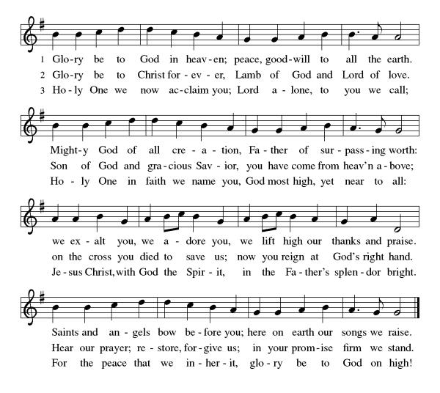

The Lord be with you. **And also with you.**

**Prayer of the Day:** Let us pray

Living God, **in Christ you make all things new. Transform the poverty of our nature by the riches of your grace, and in the renewal of our lives make known your glory, through Jesus Christ, our Savior and Lord.**

**Amen.**

*Sit*

**First Reading: Jeremiah 17:5-10**

5 Thus says the Lord:  
 Cursed are those who trust in mere mortals  
  and make mere flesh their strength,  
  whose hearts turn away from the Lord.  
 6 They shall be like a shrub in the desert,  
  and shall not see when relief comes.  
 They shall live in the parched places of the wilderness,  
  in an uninhabited salt land.  
 7 Blessed are those who trust in the Lord,  
  whose trust is the Lord.  
 8 They shall be like a tree planted by water,  
  sending out its roots by the stream.  
 It shall not fear when heat comes,  
  and its leaves shall stay green;  
 in the year of drought it is not anxious,  
  and it does not cease to bear fruit.  
 9 The heart is devious above all else;  
  it is perverse—  
  who can understand it?  
 10 I the Lord test the mind  
  and search the heart,  
 to give to all according to their ways,  
  according to the fruit of their doings.

Word of God, Word of life, **Thanks be to God**

**Psalm: Psalm 1** *to be sung*

### 

1 Happy are they who have not walked in the counsel **|** of the wicked,  
  nor lingered in the way of sinners, nor sat in the seats **|** of the scornful!  
 2 **Their delight is in the law | of the Lord,**  
  **and they meditate on God’s teaching | day and night.**

3 They are like trees planted by streams of water, bearing fruit in due season, with leaves that **|** do not wither;  
  everything they **|** do shall prosper.  
 4 **It is not so | with the wicked;**  
  **they are like chaff which the wind | blows away.**  
 5 Therefore the wicked shall not stand upright when **|** judgment comes,  
  nor the sinner in the council **|** of the righteous.  
 6 **For the Lord knows the way | of the righteous,**  
  **but the way of the wicked shall | be destroyed.  Amen**

**Second Reading: 1 Corinthians 15:12-20**

12 Now if Christ is proclaimed as raised from the dead, how can some of you say there is no resurrection of the dead? 13 If there is no resurrection of the dead, then Christ has not been raised; 14 and if Christ has not been raised, then our proclamation has been in vain and your faith has been in vain. 15 We are even found to be misrepresenting God, because we testified of God that he raised Christ—whom he did not raise if it is true that the dead are not raised. 16 For if the dead are not raised, then Christ has not been raised. 17 If Christ has not been raised, your faith is futile and you are still in your sins. 18 Then those also who have died in Christ have perished. 19 If for this life only we have hoped in Christ, we are of all people most to be pitied.  
  20 But in fact Christ has been raised from the dead, the first fruits of those who have died. Word of God, Word of life, **Thanks be to God**

*Stand*

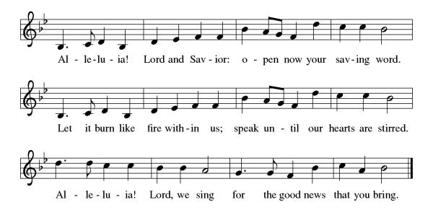

**Gospel: Luke 6:17-26**

The holy Gospel according to Luke.  
**Glory to you, O Lord.**

17 [Jesus] came down with [the twelve] and stood on a level place, with a great crowd of his disciples and a great multitude of people from all Judea, Jerusalem, and the coast of Tyre and Sidon.18 They had come to hear him and to be healed of their diseases; and those who were troubled with unclean spirits were cured. 19 And all in the crowd were trying to touch him, for power came out from him and healed all of them.  
  20 Then he looked up at his disciples and said:  
 “Blessed are you who are poor,  
  for yours is the kingdom of God.  
 21 “Blessed are you who are hungry now,  
  for you will be filled.  
 “Blessed are you who weep now,  
  for you will laugh.  
  22 “Blessed are you when people hate you, and when they exclude you, revile you, and defame you on account of the Son of Man. 23 Rejoice in that day and leap for joy, for surely your reward is great in heaven; for that is what their ancestors did to the prophets.  
 24 “But woe to you who are rich,  
  for you have received your consolation.  
 25 “Woe to you who are full now,  
  for you will be hungry.  
 “Woe to you who are laughing now,  
  for you will mourn and weep.  
  26 “Woe to you when all speak well of you, for that is what their ancestors did to the false prophets.”

The Gospel of our Lord.  
**Praise to you, O Christ.**

*Sit***SERMON**

*Stand*

**HYMN OF THE DAY- *ELW 726 Light Dawns on a Weary World***

**Apostles Creed***Baptized into Christ, with the whole Church, let us confess our faith.*

**I believe in God, the Father almighty,**

**creator of heaven and earth.**

**I believe in Jesus Christ, God’s only Son, our Lord,**

**who was conceived by the Holy Spirit,**

**born of the virgin Mary,**

**suffered under Pontius Pilate,**

**was crucified, died, and was buried;**

**he descended to the dead.**

**On the third day he rose again;**

**he ascended into heaven,**

**he is seated at the right hand of the Father,**

**and he will come to judge the living and the dead.**

**I believe in the Holy Spirit,**

**the holy catholic church,**

**the communion of saints,**

**the forgiveness of sins,**

**the resurrection of the body,**

**and the life everlasting. Amen.**

**PRAYERS OF INTERCESSION  
AM:** Each petition concludes: God of grace, **receive our prayer.**

*The pastor concludes the prayers*We commend these prayers to you, O God, trusting your grace made known to all, through the Word made flesh, Jesus Christ, our Savior and Lord. **Amen.**

**PEACE**

The peace of Christ be with you.  **And also with you.***A sign of peace and reconciliation is shared among worshippers.*

*Sit*

**Choir Anthem**- Lead Me Lord

*AM sets the table*

*AM collects offering in front of altar from acolyte*

*Our offering is presented for the work of the church locally and throughout the world.*

*Stand*

**Offering Prayer**

**AM:** Let us pray: God of grace, **your love reaches to the heavens, and your abundance to the depths of the seas. Bless what we offer to your service:**

**our gifts, our abilities, and our hearts. Let us overflow with gratitude and generosity, now and always. Amen.**

**+MEAL+**

**Great Thanksgiving**

The Lord be with you.

**and also with you**

Lift up your hearts.

**we lift them to the Lord.**

Let us give thanks to the Lord our God.

**It is right to give our thanks and praise.**

*The pastor prays the preface for the congregation.*Iti Is indeed right, our duty and our joy, That we should at all times and in all places give thanks and praise to you, Almighty and merciful God Through our Savior Jesus Christ. By the leading of a star he was shown forth to all nations;

In the waters of the Jordan you proclaimed him your beloved Son, and in the miracle of water turned to wine he revealed your glory. And so, with all the choirs of angels,’ With the church on earth and the hosts of heaven,

We praise your name and join their unending hymn:

**Sanctus**

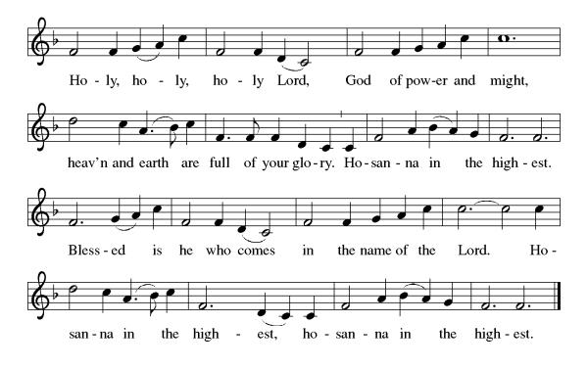

*The pastor and congregation pray the Thanksgiving at the Table.*

**Thanksgiving at the Table**

Blessed are you, O holy God…all the universe will rejoice in your holy and life-giving light…**Amen, Come Lord Jesus…**

By your Spirit bless us and this meal…revealing the brilliance of your Son.  **Amen, Come Holy Spirit.**

Through him all glory and honor is yours, Almighty Father, with the Holy Spirit, in your holy Church, both now and forever.  **Amen.**

*Gathered into one by the Holy Spirit, let us pray as Jesus taught us.*

**Our Father...**

**Invitation to communion:**

The joy of the Lord is our strength. Come, eat this meal of gladness.

*Please remain standing*

*Agnus Dei*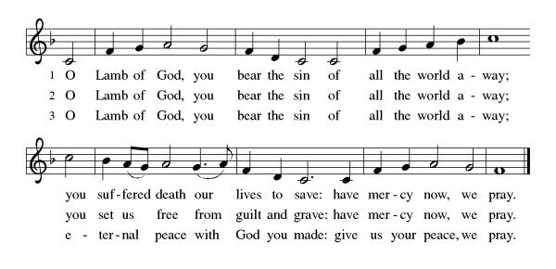**Distribution of Holy Communion***Our congregation practices eucharistic hospitality.  We believe that the resurrected Christ is truly present in the bread and wine with his gifts of life, forgiveness of sin, and salvation.  All are welcome at the Lord’s table.  Please come to the altar to receive the bread and wine.  If you are wearing a mask, remove it to eat and drink the sacrament.  If you receive the wine, take a small cup, or you may intinct the host in the chalice. Place the small cups in the baskets on either side of the altar area.  Please return to your seat by the side aisles.*

**Communion Reflection: *ELW 493 Taste and See***

**+SENDING+**

*Stand***BLESSING**The body and blood of our Lord Jesus Christ strengthen you and keep you in his grace.  **Amen.**

**PRAYER AFTER COMMUNION  
AM:** Let us pray. Nourishing God, **at this table you have refreshed us with holy gifts of food and drink. Strengthen us for service, and send us out to embody your good news of liberation and healing for the sake of the world. In the name of Christ we pray, Amen.**

**BENEDICTION**

The Lord bless you and keep you.

The Lord shine on you with grace and mercy.

The Lord look upon you with favor and + give you peace. **Amen.**

*Sit*

**ANNOUNCEMENTS**

*Stand*

**SENDING HYMN- *ELW 710 Let Streams of Living Justice***

**Dismissal:** Go in peace. Live in hope. **Thanks be to God.**

**Postlude-** Moderato, by Gebhardi

***Sundays and Seasons v.20220215.1125  
Copyright © Augsburg Fortress. All rights reserved.***

**Announcements**

**Confirmation Classes** will be held on the 1st and 3rd Sundays, following worship.

**Adult Education**, Mondays at 6:30. E-mail Pastor Kohl and he will give you the information to connect to zoom.

**Assistants Needed**

Assistants are needed for Ash Wednesday, March 5 at a 5:30 service**.**

Acolytes are needed for the next few Sundays Please help if you can.

Just sign your name on the worship assistant sheet near the coat racks.

If anyone could help with ordering flowers for Easter it would be great. Otherwise, there will be no flowers on the altar.

**Ongoing Prayers for:**

*For additions or deletions please e-mail or call the church office.789-7776, or* [*lcgsmail@gmail.com*](mailto:lcgsmail@gmail.com)

Jocleyn Theroux

Amy Hinkle

Karin Kohl

Traci Purvis

Jessica Maynard

Bobbie Peterson

C. Duncan

Margaret Franks

Billy Wernquest

Ruth Wernquest

Holly Deutsch

Mary Jane Briggs

Bill Deutsch

Gary Durett

Natalie Schanck

Mike Carty

Barbara Smith

Phyllis Farley

Brian Mitchell

Barney

Joyce Pearson

Amy Phillipo

James Meyers

Naomi Sawyer

Carolyn Hathaway

Betty Hathaway

The Greer family

Karolyn Lee

Liam Varnelis

Josh Peterson

Kathy Lee

Chris Rose

Lisa Ferry  
Ellora Hendrickson

Melvin Platt

KC Christensen

Jan Briggs

Ruth McGuy

Bud Godwin

Lisa Lessman

Taylor Lessman

Joan & Sheldon Pratt

Jerry Paquin

Stanley Larson

Ellen Hedlund

Donald & Bernadine Cunnigen

Maggie Reichgott

Tucker Maute

Karen Perry

Mark Quinn

Tim Diskin

**+LOVED ONES IN THE ARMED FORCES**+ Manny Morales, Michael Bock

Matthew Kankash, Heath O’Neill, Andrew Anderson, Noah Cooper, Dan Berkowitz